Sustainable Winter Tourism DEVELOPMENT Project

Request for Proposal (RFP)

Date: 20 September 2019

From: Helvetas Swiss Intercooperation
65, 7-ya liniya, Bishkek
Kyrgyzstan

Subject: DEVELOPMENT AND DELIVERY OF A SERIES OF HOSPITALITY TRAININGS

Dear Potential Bidder,

Helvetas Swiss Intercooperation invites your company to submit a proposal in support of its Sustainable Winter Tourism Development Project, funded by SECO.

Please note the following deadlines in responding to this Request for Proposal:

- QUESTIONS: Questions regarding this tender can be sent to Nazira.Jamankulova@helvetas.org until 17:00 on Friday, 27 September 2019.

- PROPOSAL SUBMISSION: Tender proposals must be prepared in the Russian language and submitted no later than 5:00 pm, Tuesday, 08 October 2019 to the email: Nazira.Jamankulova@helvetas.org with cc to kyrgyzstan@helvetas.org

Thank you for your interest in this tender. We look forward to working with your organization on this opportunity.

Annexes:
Annex 1 – Terms of Reference
Annex 2 – Budget Template

TERMS OF REFERENCE
DEVELOPMENT AND DELIVERY OF A SERIES OF HOSPITALITY TRAININGS

- Background
This SECO funded project aims at strengthening and developing further the tourism sector in Kyrgyzstan. The main objective of the project is to develop a competitive and sustainable Winter Tourism value chain in the select destinations. This goal shall be achieved, on the one hand, by developing necessary skills for service providers and, on the other hand, by creating favorable framework conditions to enable access to the Winter Tourism value chain for small scale entrepreneurs and local population. The Sustainable Winter Tourism Development Project (hereinafter referred to as Winter Tourism Kyrgyzstan or WTK) is a direct response to some the key problems in the Kyrgyz tourism sector: short seasonality & a lack of qualified staff.
WTK Project started its operation from 01 April 2019 by HELVETAS Swiss Intercooperation which had been selected through an open tender for the implementation of the first phase (pilot phase) covering April 2019 – March 2021. During the 6-month inception phase (April – September 2019), WTK undertook assessments in both target destinations – Karakol and Bishkek South to develop a detailed Action Plan for the Pilot Phase. One of the assessment findings was a skills shortage at different levels (top management, middle management and entry-level staff), for the different hospitality ventures (hotels, restaurants, guesthouses, homestay) and regarding the different profiles of employees (age, localization, local/foreign experience, with/without hospitality education).
Interviews with the stakeholders revealed that hotels in Kyrgyzstan have difficulties to meet the rising demand for quality services. New units are opening resulting in an important pressure on a limited pool of skilled workforce. There is limited qualified staff available in the market contrasting with a substantial growth of hospitality graduates willing to migrate for better-paid jobs to foreign countries. This lack of qualified professionals is a threat to the development of the sector. As the number of recent graduates is not sufficient for the market and newly recruited employees are not up to the standards, problems arise to fit the needs of visiting tourists.
Data collected through the different vocational training schools demonstrates that the demand for hospitality training is on the raise. Youth are aware of opportunities of employment and self-employment, and encouraged by their families to follow this career path. Current students are coming from all over Kyrgyzstan and a relatively high number of them are already planning to become self-supporting by developing a homestay, a yurt camp or a hostel which would give them the opportunity to create a good future for themselves and involve their families. Considering the sector globally, it is therefore crucial to respond to the requirements of hotels as well as smaller ventures.
- Objective
Across the various types of hospitality businesses two main training needs have been identified: customer service and hospitality soft skills. The main objective of this activity is to procure the services of a hospitality service training provider to design and deliver a series of hospitality training(s) to enhance skill sets and knowledge transfer amongst the hospitality professionals across target destinations – Karakol and Bishkek South. Training is expected to target three levels of hospitality staff 1) top management, 2) middle management and 3) entry-level staff.

As a result of the cooperation described in these ToR, WTK expects to a) have materials, methodologies and expertise available in Kyrgyzstan to conduct relevant hospitality trainings, and b) to have first cohorts of hospitality managers trained to ensure quality customer service and improved soft skills among hospitality staff.

- Main Tasks and Activities

Development of new short industry trainings for customer service and soft skills

The inception phase revealed a wide range of existing training with various durations, levels and modalities.
Specific areas of intervention have been identified in the training needs assessment that concern the entire range of service providers, from homestay to hotels. The following two priorities have been defined:

- Customer service, which embraces various topics to enhance guest satisfaction and create a unique experience;
- Soft skills in hospitality which mainly includes problem-solving, interpersonal and socio-professional skills.
Short-term training curricula and teaching materials are to be developed jointly by a successful bidder and the Swiss Association of Hoteliers - Hôtelleriesuisse with the involvement of the Helvetas Hospitality Training Adviser, to train a pool of Master Instructors. These experienced professionals are expected to conduct 3-day trainings to improve service delivery and overall management of guesthouses, hotels and homestay to contribute to the professionalization of the hospitality services and comply with the high standards required.

An additional framework, including a mystery shopping component, might be developed at a later stage to improve customer service standards and quality assurance.

Training of Master Instructors

In Kyrgyzstan, while vocational training generally involves practitioners most of the tertiary education courses are delivered by teachers with theoretical background. Data demonstrates that there is a need for on-the-job management training involving experienced industry professionals: a training scheme from the industry to the industry.

A successful bidder is expected to train Master Instructors who will be able to pass on further knowledge and pedagogical skill on how to deliver training in customer service and hospitality soft skills in target destinations. This training scheme will follow a cascading model through a Training of Trainers (ToT) system.

As a first step, a successful bidder is expected to select a pool of 15 Master Instructors, all industry professional with complementary background such as working in different hospitality occupations (F&B, Rooms, Kitchen…), coming from different locations (Karakol and Bishkek) or having a supervisory level in different types of hospitality businesses (hotel, guesthouse, restaurant, homestay). These Master Instructors should be available on demand and have sufficient experience at supervisory level.

Roll Out Training across Target Destinations

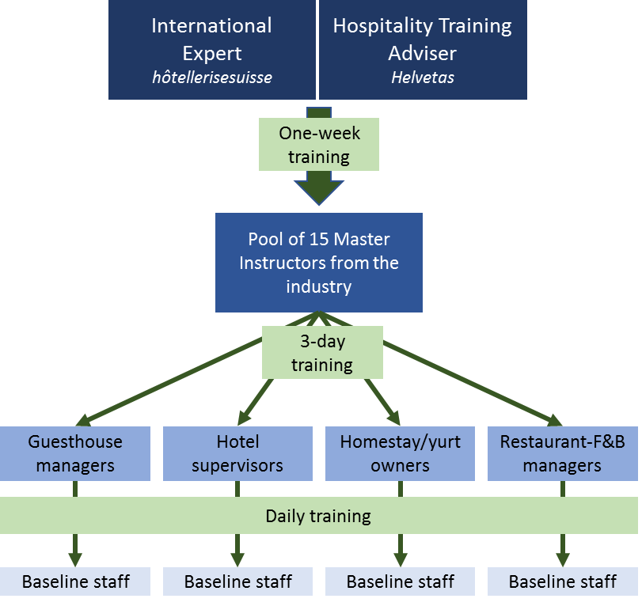
In a second stage, Master Instructors will deliver a soft skills course to supervising and managing staff of the hospitality sector. The objective is to equip them with the necessary competencies to train their own line staff.
Training scheme
Targeted businesses should be interested to improve customer service. The training is open to all hospitality partners such as hotels, guesthouses, homestay or restaurant who are committed to delivering a certain number of training hours to their line staff.
The proposed industry training does not only intend to fulfill tourists’ requirement but to meet all stakeholders’ expectations from locally employed staff to entrepreneurs and professional partners in order to contribute to socio-economic development and to increase job opportunities.

A successful bidder (an Implementing Partner) is expected to specifically undertake the following tasks:

- Review the results of the target destination assessments completed in September 2019 by WTK, revise the existing training programs and propose a training work plan;
- Identify a cadre of recruits from 2 target destinations, who are willing and intend to serve as Hospitality Master Instructors;
- Together with CH partners, develop a series of training modules for different categories 1) top management, 2) middle management and 3) entry-level staff based on assessment results, review of existing programs as well as international best practices;
- Provide logistical coordination, support and leadership throughout the conduct of the trainings in both target destinations.

- Expected Results & Deliverables

Deliverables will include:

- Hospitality training programs and curricula developed under this assignment;
- Finalized training schedule, materials, and resumes and qualifications/profiles of proposed trainers;
- Training report, inclusive of:
  - Overview and description of trainings (locations, numbers, key info);
  - Provision of training materials for all three levels;
  - Recommendations on next steps for the KG hospitality sector in general and WTK in particular;
  - Photos and media files, as well as testimonials of participants.
- The list of Master Instructors with contact details and the list of trainees whom have successfully completed the training program, across destinations, along with levels of competency and skills attained.

Tentative Time Frame
November 2019 – March 2020. An exact timeline and schedule will be agreed with the successful bidder. The total expected number of the working days within this time frame is 30 days.

- Reporting
Weekly informal updates to the project manager and to the project team.

Guidelines for writing a tender proposal:

- Technical Proposal Content
Technical Approach Description no more than three (3) pages. Please describe the approach, methodologies and tools you would apply for the development and delivery of the hospitality training.
The following criteria will be used to evaluate the bidding organizations and their tender proposals:
- Clarity and comprehensiveness of the proposal (approach, tools, timeline, etc.).
- Experience of the team members in the hospitality training.
- Organizational capability to perform the task and be a long-term partner for the Swiss organization.

- Team composition

An interested bidder is expected to propose the team of knowledgeable experts/trainers with relevant experience in hospitality curricula development and training delivery. Please provide a CV for each proposed expert/trainer.

- Cost Proposal

For the cost proposal, please fill out the attached Budget Template. Your cost proposal should be presented in Kyrgyz Soms. Please estimate logistics cost for 2 training workshops to be held in Bishkek and Karakol.

- Past Performance

Please provide at least 2 examples of past performance activities that are similar in nature to the efforts identified in these Terms of Reference and that indicate your organization’s and the recommended experts’ experience to perform this task. Please also provide name(s), e-mail addresses, and phone numbers of the customer(s) to whom the services were provided, dates and periods during which the indicated services were provided.

